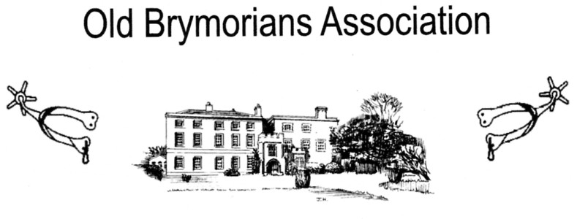

BRYMORE ACADEMY, BRYMORE WAY

CANNINGTON, BRIDGWATER, SOMERSET TA5 2NB

TEL 01278 652369

Chairman: Peter Harris, Huntsgate Bungalow, Huntscott, Wootton Courtenay, Minehead, TA24 8RR Tel 01643 841729 email: pgh_harris@btinternet.com
Secretary: Rex Eastment, White Horse View, Farleigh Hungerford, Bath BA2 7RR
Tel 01225 762975 email: rexeastment@talktalk.net
Honorary Jenny Harris, Huntsgate Bungalow, Huntscott, Wootton Courtenay, Minehead
Treasurer: TA24 8RR Tel 01643 841729 email: jharris_moonshine@btinternet.com

Dear Old Brymorian, May 2020

It is with regret that I have to inform you that 2 former teachers and Deputy Headmasters have
passed away - Colin Munro in early March, and sadly Alan Hemming towards the end of April.
In both cases I have written letters of condolence to their families on behalf of the Association.

We have been advised by Mark Thomas, Head Teacher that the annual Open Day and Country Fair
held at Brymore at the end of June has regrettably been cancelled because of the ongoing Corvid-19
Pandemic. This means that the OBA will not be holding their Summer Draw this year and the
Annual General Meeting will be held in abeyance for the time being.

As the Summer Draw is not now taking place, and this is our main fundraising effort each year,
we are hoping that you might consider making a donation to OBA funds instead of purchasing the usual
draw tickets. Any monies/cheques received would be banked when we are out of lockdown and it is
safe to do so. Please contact Jenny or Rex for details of how this could be done by bank transfer
(BACS) into the OBA account if you would prefer to do it this way.

Looking further ahead to Pym’s Night Supper – if this can go ahead we will send out details later in
the year.

I must apologise for being the bearer of all this negative news, but we live in very uncertain times
but I am sure the Brymore spirit will prevail.

Kind regards

Peter
Chairman of the Old Brymorian’s Association

