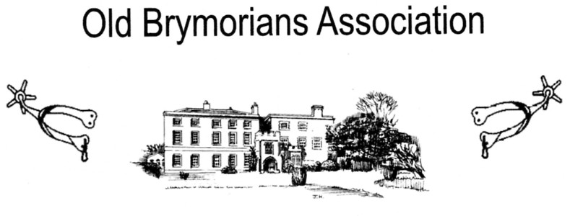

In accordance with the Old Brymorian’s Association Constitution,

If you wish to present any resolutions (propositions) for discussion at the Annual General Meeting, they must be presented to the secretary by the 15th. June 2019.

The Annual General Meeting will be held at Brymore Academy on 29th. June 2019 commencing at 5.00 pm in the Old Dining hall.

Rex Eastment
Secretary
rexeastment@talktalk.net

