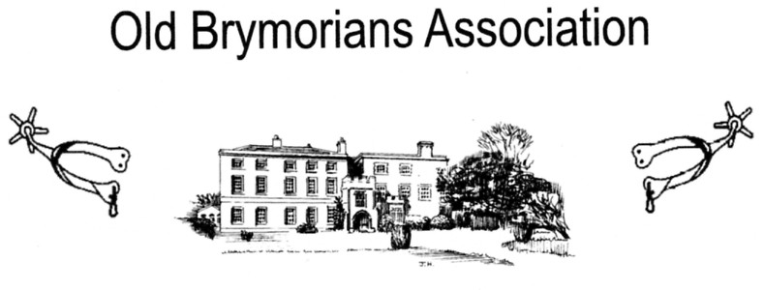

BRYMORE ACADEMY
BRYMORE WAY, CANNINGTON, BRIDGWATER, SOMERSET. TA5 2NB
Tel: 01278 652369 Fax 01278 653244

Chairman: Peter Harris, Huntsgate Bungalow, Huntscott, Wootton Courtenay, Minehead.
TA24 8RR Tel: 01643 841729 email: pgh_harris@btinternet.com
Secretary: Rex Eastment, White Horse View, Farleigh Hungerford, Bath. BA2 7RR
Tel: 10225 762975 email: rexeastment@talktalk.net
Honorary Jenny Harris, Huntsgate Bungalow Huntsgate, Wootton Courtenay, Minehead.
Treasurer: TA24 8RR Tel: 01643 841729 email: jharris_moonshine@btinternet.com

Dear Old Brymorian, May 2019

Once again, the date for Brymore Open Day and Country Fayre is fast approaching; this year it will
be held on Saturday 29th. June from 10.00 am. and if you can come along it will be good to see
You. It is, as many of you are already aware, an entertaining family day out with many attractions
for young and old alike. It will also provide a wonderful opportunity to meet old friends and renew
past acquaintances.

The Old Brymorian’s Association will be based as usual in The Learning Resource Centre (old Library) where tea, coffee, soft drinks and biscuits will be served throughout the day. You will be
Able to look through our memorabilia which has been collected over the years and reminisce about
Your days at Brymore to others.

The Old Brymorian’s Association Annual General Meeting, which is open to all old boys, will be held at 5.00 pm in part of the Old Dining Room, pre-buffet drinks will be available in the Learning Resource Centre from 6.00 pm. And will be followed by the Buffet Supper at 7.00 pm in the current
Dining Room. The catering for this year’s buffet will be carried out by Aspens who were awarded the catering contract for providing the food for the Academy in November 2018.

As usual the OBA Committee are enclosing 2 books of Summer Draw Tickets. Please return any monies and counterfoils or UNSOLD BOOKS OF TICKETS together with the Buffet Supper Acceptance Form to Jenny Harris, OBA Honorary Treasurer by 19th. June 2019 please.

Kind regards

Peter

Chairman of the Old Brymorian’s Association

