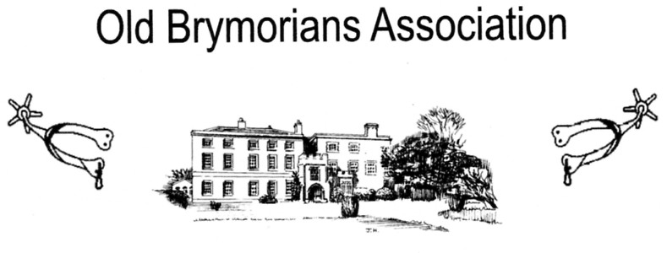

In accordance with the Old Brymorian’s Association Constitution,

If you wish to present any resolutions (propositions) for discussion at the Annual General Meeting, they must be presented to the secretary by the 24th. June 2023

The Annual General Meeting will be held at Brymore Academy on 24th. June 2023 commencing at 5.00 pm in the ‘Café’ (next to the main Hall.)

Rex Eastment
Secretary
eastmentrex2@gmail.com

