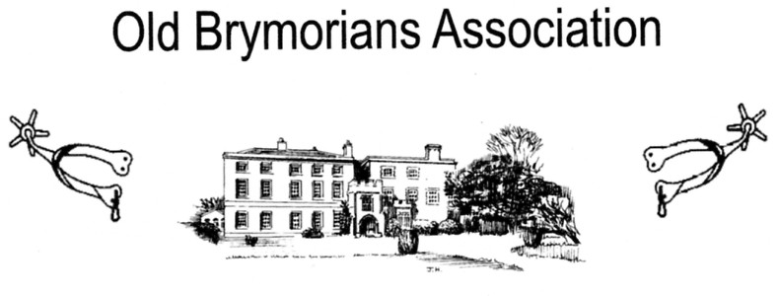

BRYMORE ACADEMY
BRYMORE WAY, CANNINGTON, BRIDGWATER, SOMERSET. TA5 2NB
Tel: 01278 652369

Chairman: Ollie Mahon, Brow Lodge, Church Road, Combe Down, Bath. BA2 5JL. Mobile: 07901 885349 email: obachair52@gmail.com
Secretary: Rex Eastment, White Horse View, Farleigh Hungerford. Bath BA2 7RR. Tel: 01225 762975. email: eastmentrex2@gmail.com
Honorary Jenny Harris, Huntsgate Bungalow Huntsgate, Wootton Courtenay, Minehead.
Treasurer: TA24 8RR Tel: 01643 841729 email: jharris_moonshine@btinternet.com

Dear Old Brymorian, May 2023

Once again, the date for Brymore Open Day and Country Fayre is fast approaching; this year it will
be held on Saturday 24th. June from 10.30 am. and if you can come along, it will be good to see
you. It is, as many of you are already aware, an entertaining family day out with many attractions.
for young and old alike. It will also provide a wonderful opportunity to meet old friends and renew.
past acquaintances.

The Old Brymorian’s Association will be based in the Brymore Café which is adjacent to the old dining hall where tea, coffee, soft drinks, and biscuits will be served throughout the day.
You will be able to look through our memorabilia which has been collected over the years and reminisce about Your days at Brymore to others.

The Old Brymorian’s Association Annual General Meeting, which is open to all old boys, will be held at 5.00 pm in the Brymore Café. Pre-buffet drinks will be available from 6.00 pm. and will be followed by the Buffet Supper at 7.00 pm in the current Dining Room.

As usual the OBA Committee are enclosing 2 books of Summer Draw Tickets.
Please return any monies and counterfoils or UNSOLD BOOKS OF TICKETS together with the Buffet Supper Acceptance Form to Jenny Harris, OBA Honorary Treasurer by 17th. June 2023 please.

Kind regards

Ollie

Chairman of the Old Brymorian’s Association

