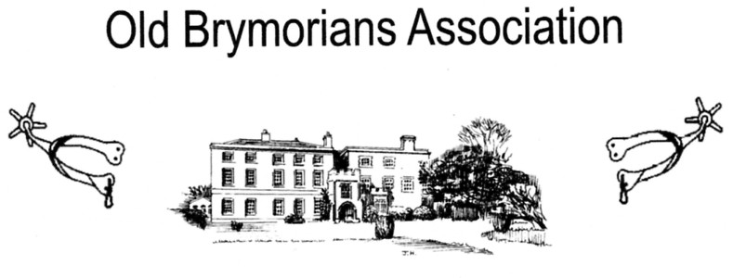
BRYMORE ACADEMY

Old Brymorian’s Buffet Supper

Saturday 30th. June 2018

7.00 pm

Acceptance Form

Please reserve ______________ places at £8.50 per person (vegetarian/gluten free option available)

I enclose a cheque for £____________

From ___________________________________________________

Please return with cheque (made out to Old Brymorian’s Association) by 18th. June 2018 to:-

OBA Treasurer: Jenny Harris, Moonshine, Chapel Leigh, Lydeard St Lawrence, Taunton. TA4 3RB

_ _ _ _ _ _ _ _ _ _ _ _ _ _ _ _ _ _ _ _ _ _ _ _ _ _ _ _ _ _ _ _ _ _ _ _ _ _ _ _ _ _ _ _ _ _ _ _ _ _ _ _
Important Notice:
The General Data Protection Regulation (GDPR) comes into effect on 25th. May 2018 and will overhaul how businesses process and handle data. For that reason we need consent from you to continue to hold information about you on our OBA database after this date.

If you wish to remain on the OBA database and to continue to receive information, emails, events letters and copies of the Spur Magazine from the Old Brymorian’s Association: then no further action is needed.

If, however you no longer want your details held on the OBA database, Please complete the relevant details below and your details will be deleted on the 25th. May 2018.

Name: ……………………………………………………………………….

email address: ……………………………………………………………..

Address: ………………………………………………………………………………………………………………

…………………………………………………………………………………………………………………………

Post code: ………………………..

