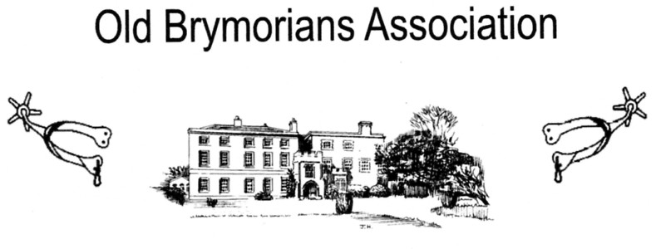

Chairman: Peter Harris, Moonshine, Chapel Leigh, Lydeard St.Lawrence, Taunton TA4 3RB Tel: 01984 667272 – email: pgh_harris@btinternet.com
Secretary: Rex Eastment, White Horse View, Farleigh Hungerford, Bath BA2 7RR
Tel: 01225 762975 – email: rexeastment@talktalk.net
Honorary Jenny Harris, Moonshine, Chapel Leigh, Lydeard St Lawrence, Taunton
Treasurer: TA4 3RB Tel: 01984 667272 – email: jharris_moonshine@btinternet.com

1st. September 2017

Dear Old Brymorian,

This year, Pym’s Night Supper will take place on Saturday, 21st. October at Brymore Academy with arrival from 5.30 pm for the drinks reception, supper at 7.00 pm, and the evening closing at 10.30 pm; all times are approximate.
Our Guest Speaker for the evening will be Mr Les Davies, MBE, a retired Mendip Hill Warden and known to many as “The West Countryman.” Some of you may remember that Les had a regular slot on local radio and is well known for his story telling and humour.

You will find further details enclosed with this invitation concerning menu choices and the cost of the meal. Numbers we can cater for are limited, so please be prompt with your reply to avoid disappointment. The closing date for final numbers will be Saturday, 7th. October, we are sorry that we cannot accommodate requests after this date.

Thank you again for your continued support of the Old Brymorian’s Association.

Kind regards

Peter
Chairman of the OBA

Please Note that all returns are to be sent to Jenny Harris, the
Association’s new Honorary Treasurer at the above address.
Thank You

